**********************LIST OF ERRORS FOR ACE INDUS .US **************************
- In home page, when we click on training category, the page is not found for class room training & online training page is http://aceindus.us/ittraining/
- Instead of News events change to News & Events http://aceindus.us/newsevents.html in home page
http://aceindus.us/sitemap.html
- There are no links for IT COMPANY sub categories the page is http://aceindus.us/sitemap.html#
- This page is under construction http://aceindus.us/logistics.html
- This page is under construction http://aceindus.us/alliances.html
- This page is under construction http://aceindus.us/clients.html
- This page is under construction http://aceindus.us/partnerships.html
- This page is under construction http://aceindus.us/business.html
- When we click any category of Academic in home page. The page is under construction http://www.aceindus.us/academic/
- In site map page, under web solution category the name portfolio ‘P’ should be capital letter.
http://aceindus.us/sitemap.html
- This page is under construction http://aceindus.us/design_development.html
- 12. This page is under construction http://aceindus.us/graphic_designing.html
- 13. This page is under construction http://aceindus.us/products.html
- 14. There is no colon for sub headings in http://aceindus.us/software_development.html & http://aceindus.us/crm_applications.html
- 15. There are no colons for sub headings in http://aceindus.us/benefits.html
- 16. . This page is under construction http://aceindus.us/post_yourresume.html
- 17. All Other Names Used (Include maiden name and names from all previous marriages) instead of this we can write All Other Names Used (Include maiden name and name before marriage).
- No functionality of save & continue button. Actually it should be converted to .aspx page
- http://aceindus.us/new_employeeform.html
- 18. This page is under construction http://aceindus.us/support.html
- 19. There is no functionality if submit button clicks in http://aceindus.us/feedbackform.aspx
- 20. This page is under construction http://aceindus.us/accounting.html
- 21. This page is under construction http://aceindus.us/interview_tips.html
- This page is under construction http://aceindus.us/job_seekers.html
- This page is under construction http://aceindus.us/recruitment.html
- This page is under construction http://aceindus.us/find_ajob.html
- This page is under construction http://aceindus.us/graphic_designing.html
- This page is under construction http://aceindus.us/design_development.html
- This page is under construction http://aceindus.us/products.html
- This page is under construction http://aceindus.us/support.html
- 22. Contact us name should be changed to contact in http://aceindus.us/sitemap.html
- 23. There is no colon for sub headings in http://aceindus.us/consulting.html ,
- http://aceindus.us/software_development.html , http://aceindus.us/benefits.html , http://aceindus.us/Permanent_Staffing.html & http://aceindus.us/projectmanagement.html
- 24. Instead of Overview write company overview in page http://aceindus.us/companyoverview.html

- 25. There is no functionality of submit button in this page http://aceindus.us/new_employeeform.html

- 26. When we click on login in home page, the error is http://aceindus.us/login.aspx
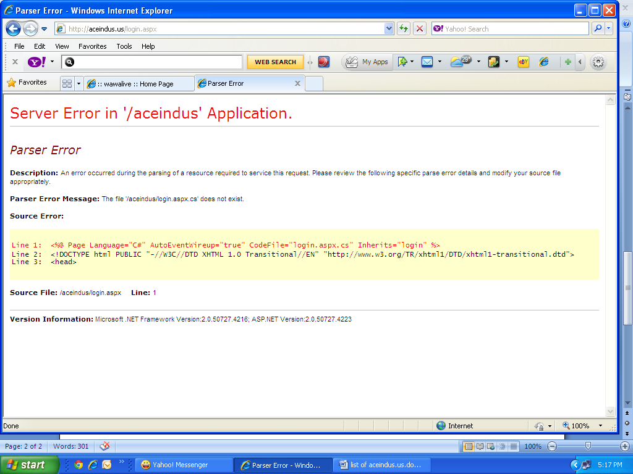

- 26. When we click submit button in http://aceindus.us/postresume.aspx . The error is

*********************Admin Errors*************************
- When we open admin login error is found the page is 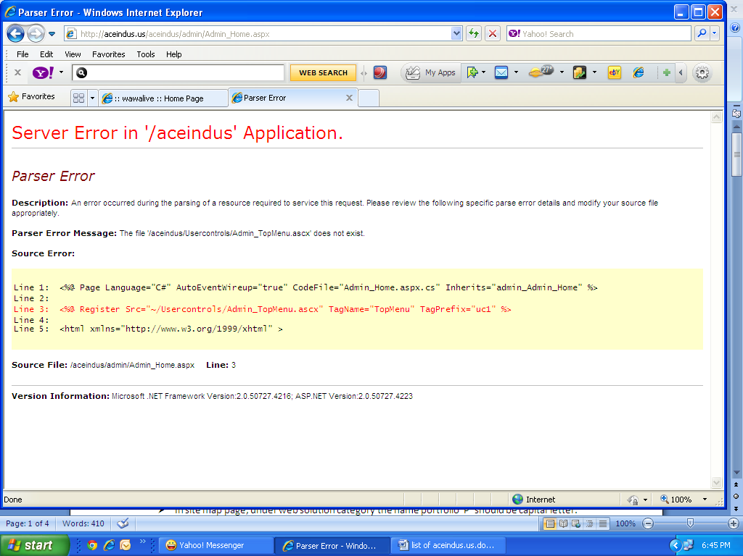
- When we want to post any resume the error is
